FULL SEO · PROJECT MANAGEMENT SAAS
How a Full-SEO Strategy Grew a Project Management SaaS by 84%
On-page optimization | Technical SEO | Link building

71 → 75  DR growth  +4 pts | 84%  Traffic increase  +35K visitors | 300+  Backlinks built | +2.3K  New organic keywords  +35% growth

Overview
Our client is a project management SaaS platform helping teams plan resources, track budgets, and manage projects end-to-end. Operating in one of the most competitive SaaS niches, they needed to meaningfully increase organic visibility and outrank well-established competitors for high-intent keywords.
We implemented a comprehensive Full SEO strategy — combining consistent blog content publishing, on-page optimization, technical improvements, and 300+ high-quality backlinks — to drive sustainable, compounding growth.

Overall site performance
The numbers below reflect the year-over-year growth. DR climbed from 71 to 75, organic traffic jumped by over 35K monthly visitors — an 84% increase — and the site's organic keyword pool grew by 35%, adding 2.3K new keywords over the period.
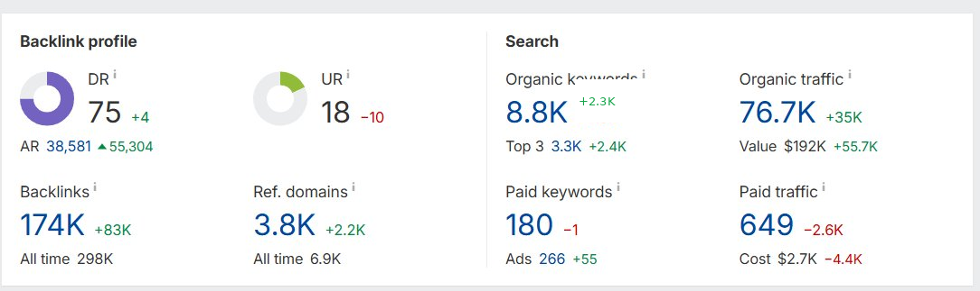

Keyword performance highlights
Three keywords that illustrate the range of results — from a jump to #1 on a core term, to a brand-new competitive keyword already breaking into the top 3.
Keyword #1 — position 9 → 1
Volume 900 KD 11 Position change ▲8

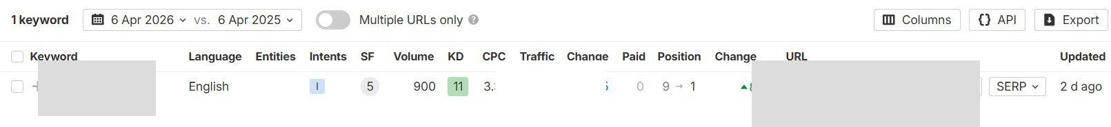
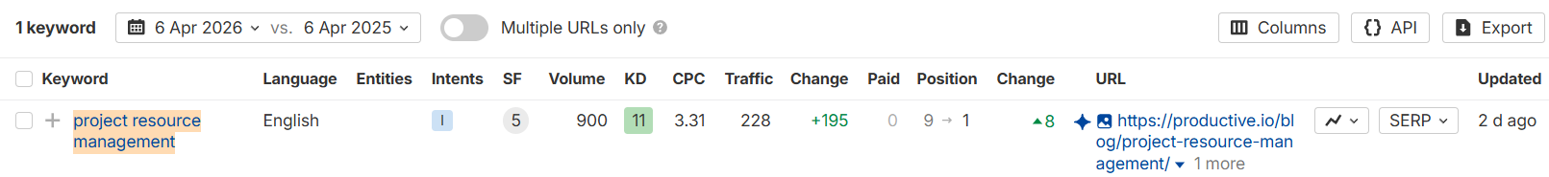

With a KD of just 11 and 900 monthly searches, this was a high-priority target. The page climbed from position 9 all the way to #1, driving +195 in traffic from this keyword alone — a direct result of consistent content quality and authority building.

Keyword #2 — position 52 → 1
Volume 600 KD 10 Position change ▲51

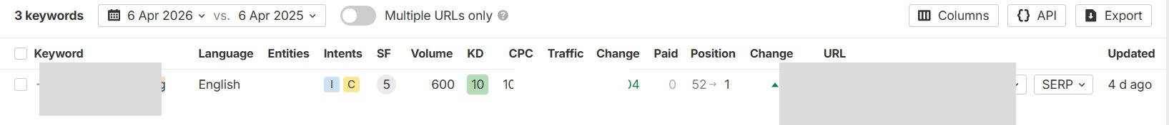
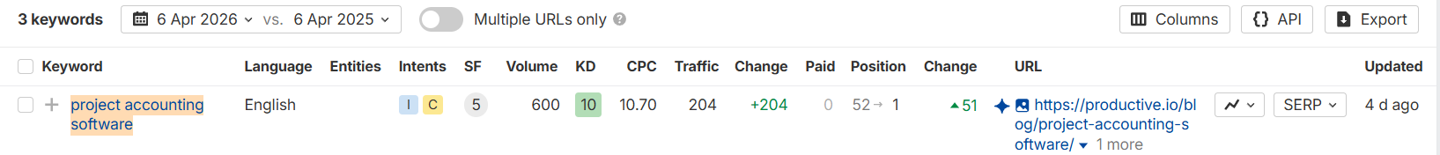
The standout result of this case study. The page moved 51 positions — from page 5 to the very first result on Google — generating +204 in traffic, up from virtually zero. This is what happens when optimized content meets growing domain authority and targeted link building.
Keyword #3 — new entry at position 3
Volume 150 KD 80 Position Not ranked → #3

Despite a high difficulty of 80, this page entered the rankings fresh and immediately landed at position 3. Even on more competitive terms, the domain authority built through 300+ backlinks and ongoing optimization work is already showing results.

What drove these results
This growth came from four consistent pillars running in parallel — not a single tactic.

Consistent blog publishing  We regularly produced and published new blog articles targeting high-opportunity keywords, creating new organic entry points month after month. | On-page optimization  Existing pages were continuously reviewed — updating meta data, improving content structure, strengthening internal links, and aligning pages with search intent.
300+ backlinks built  We built over 300 unique backlinks from relevant, high-authority domains, steadily growing the site's domain rating from 71 to 75. | Technical improvements  Crawlability, indexation, and Core Web Vitals issues were resolved on an ongoing basis, ensuring nothing technical held back organic potential.

